Introduction.................................................................................................................................03

Business Objective.......................................................................................................................03

1. Identifying stakeholders...................................................................................................06

2. Identifying risks in this new feature................................................................................06

3. SWOT analysis for WhatsApp Pay feature......................................................................07

4. Identifying the Transition State of WhatsApp Pay..........................................................09

5. As-is and future process map (using flowcharts)............................................................10

6. Scope of this system using Context diagram...................................................................12

7. Main features that need to be developed.........................................................................12

8. In scope and out-of-scope items for this software...........................................................13

9. Business Requirements, Functional and Nonfunctional Requirements...........................14

10. Wireframes of the features................................................................................................15

Key Assumptions and Constraints................................................................................................15

# Introduction

WhatsApp is a messaging and Voice over IP (VoIP) service owned by Facebook. It allows users to send text and voice messages, make voice and video calls, and share images, documents, and other media. WhatsApp runs on mobile devices but is also accessible from desktop computers. WhatsApp has over 2 billion users worldwide as of today. It has become the primary means of electronic communication in multiple countries across multiple continents, including Latin America, the Indian subcontinent, and large parts of Europe and Africa.

Today across the globe people are moving to digital payment services such as Google Pay, PhonePe, PayPal and others. Mobile wallets are in massive demand. The transaction value of the global mobile payments market was USD 2.98 trillion in 2023 and is expected to reach USD 27.81 trillion by 2032, registering a CAGR of 28.1%. WhatsApp being one of the leading mobile messaging apps wants to get a slice of this growing digital payment market.

WhatsApp has decided to take the plunge into this digital payment market. They have launched a new feature namely, WhatsApp Payments to be known as WhatsApp Pay in Brazil in June 2020. WhatsApp promises to disrupt the global digital payments ecosystem with WhatsApp Pay.

WhatsApp will integrate the customer’s debit card or credit card into their app. That is, while chatting with your peers, you can transfer the money to them. There will be no separate app that the customers need to download to access this payment feature. This feature would be provided to users as an update in the existing WhatsApp messaging app. The user can use WhatsApp pay feature by updating the WhatsApp messaging app.

# Business Objective

WhatsApp aims to leverage its massive user base and popularity as a messaging app to enter the growing digital payment market. By incorporating a payment feature directly into its messaging app, WhatsApp aims to increase user engagement and encourage users to spend more time within the app, WhatsApp also aims to gain a competitive edge by offering a convenient and user-friendly payment solution.

## Business Objective by senior management:

* Have at least 1 million users use WhatsApp pay feature within the first 3 months of launch.
* Over 1 year of its launch have 30% of user base using WhatsApp pay.

## Advantages of WhatsApp Pay:

1. **Convenience:** WhatsApp Payments is an easy and convenient way of sending and receiving payments without leaving the app.
2. **Security:** WhatsApp Payments uses end-to-end encryption, two-factor authentication, and other security features to protect user information and transactions.
3. **No additional charges:** There are no additional charges for using WhatsApp Payments. You can send and receive payments for free.
4. **Quick and instant:** Transactions through WhatsApp Payments are quick and instant, which means you don't have to wait for several hours in bank for a transaction to be completed.
5. **Easy to use:** WhatsApp Payments is easy to use and does not require any additional app or setup. It is integrated into the app, making it accessible to all WhatsApp users.
6. STAKEHOLDERS

|  |  |  |  |
| --- | --- | --- | --- |
| **External Stakeholders** | | | |
| **Sr. No** | **Stakeholders** | **Actors** | **Roles and Responsibility** |
| 1. | End Users | WhatsApp  users | Existing or new WhatsApp users who are using WhatsApp for text and voice messages, make voice and video calls, and share images, documents, and other media can also make digital payments as new feature proposed. |
| 2. | Sponsor | Meta  Platforms,  Inc | Meta Platforms Inc, formerly known as Facebook Inc, authorize the work to be performed and control the budget and scope for the initiative of new payment feature. |
| 3. | Regulator | Reserve  Bank of  India, Government, Indian Police force, TRAI, NPCI, CCI | Reserve Bank of India Provides the rules, regulations, protocols,  guidelines, liabilities of the end users with the WhatsApp Pay, and also through National Payments Corporation of India (NPCI) regulates the UPI settlements platform where the proposed WhatsApp pay feature has to be done.  TRAI - Telecom Regulatory Authority of India is a regulatory body set up by the Government of India.  CCI - Competition Commission of India is the chief national competition regulator in India. |
| 4. | Supplier | Banks | Existing and new WhatsApp app users must and should hold a bank account to use the WhatsApp pay feature and is identified by UPI platform by the 10-digit mobile number registered with bank.  Banks will have to share Bank details, Branch Details, IFSC details to show on the screen and on making payment banks will have to validate the users have accounts in respective banks. |
| Bank (debit  card  provider | Debit card providers will have to cooperate with WhatsApp to enable users to pay via respective Debit cards. Once debit card holder makes the payment in WhatsApp pay then banks system check the authenticity or correct credentials if its ok then bank need to perform account balance check and approve or disapprove the transfer. |
| Credit card  providers | Credit card providers will have to cooperate with WhatsApp to enable users to pay via respective credit cards. Once credit card holder makes the payment on WhatsApp pay then banks system should check the authenticity or correct credentials. If its ok then bank need to perform account credit check and approve or disapprove the transfer. |
| **Internal Stakeholders** | | | |
| 1. | Business Analyst |  | Business Analyst is responsible and accountable for the execution of business analysis activities, and will also ensure all the requirement are converted into the actual features in the proposed system. |
| 2. | Project  Manager |  | Project Manager is responsible for managing the work to deliver a solution for the business need/requirement. Project Manager also ensures that the project objectives are met while balancing the factors including scope, budget, schedule, resources, quality, and risk. |
| 3. | Implementation  SME |  | An implementation subject matter expert is any stakeholder who has specialized knowledge regarding the implementation of new feature without impacting the old features/functionality. |
| 4. | Domain SME |  | A domain subject matter expert is any stakeholder with in-depth knowledge of the business needs/requirements and solution scope. |
| 5. | Tester |  | Tester is any stakeholder who is responsible for verifying the solution meets the business needs/requirement that is defined by the business analyst and also ensures that the solution meets applicable quality standards, so there is no risk of any defects or failure is understood and minimized. |
| 6. | Operational Support |  | Operational support is any stakeholder who is responsible for managing and maintenance of the system or product |

1. RISK IDENTIFICATION

* Data security is the primary risk of the WhatsApp pay feature.
* How secure is the WhatsApp pay feature for users and banks as well?
* Users need a stable and healthy network to perform the payment without failure.
* If suppose there is a transaction failure, how quick is the support team to resolve the issue. As the support team needs to coordinate between both user and bank.
* WhatsApp pay feature should not show any impact on other features or functionality.
* There will be an impact on WhatsApp application reputation if the payment feature doesn’t work efficiently and smoothly.
* Will users be able to make international payments?
* WhatsApp need to regularly updated with current trend and future requirements.

## Strategy Analysis:

|  |  |
| --- | --- |
| **Knowledge Area Tasks** | **Task Details** |
| Analyze Current State | * Internal and External Stakeholder Analysis. * Analyze the current state and technical gaps of WhatsApp application. * Analyzing the other current digital payments available. |
| Define Future State | * Organizational goals and objectives that need to be achieved. * Organizational structure and defining the level of planning of scope of program. * Roles and Responsibilities of the Stakeholder. |
| Assess Risks | * Existing functionality of the application should not be impacted by the new feature. * Integration with Banks, payment gateways and other payment network operators should be secured, transparent and seamless. * Security and privacy. * Account details of user and bank should be secured, encrypted and kept safe. |
| Define Change Strategy | * Gap analysis from existing releases. * Tie up and collaboration with other players in the market. |

1. SWOT ANALYSIS

## SWOT Analysis for WhatsApp pay is explained:

1. **Strengths:**

* **Huge customer base**

WhatsApp already has a massive user base of over 2 billion users.

* **Supports All Platforms**

The app is available on all platforms, including iOS, Windows, and Android, making it accessible to everyone.

* **Technology**

WhatsApp’s biggest strengths is its superior technology and has the best connectivity.

* **Strong Brand Presence**

WhatsApp is a well-established and trusted brand in the messaging app market, which can help in gaining user trust and acceptance for its payment feature.

* **Seamless Integration**

By integrating the payment feature directly into the existing WhatsApp messaging app, users do not need to download a separate app, making it convenient and easily accessible.

1. **Weaknesses:**

* **Data Security and Privacy Concerns**

As a payment service, WhatsApp Pay needs to ensure robust security measures to protect user financial information. Any data breaches or privacy concerns could significantly impact user trust and adoption. Additional layers of security will have to added.

* **Internet**

Internet is required for the app to function, in specific regions people who does not have access to the internet is still unable to targeted.

1. **Opportunities:**
   * **Smartphone Adoption**

The main advantage of WhatsApp is the global penetration and adoption of smartphones.

* + **Expansion into Emerging Economies:**

WhatsApp Pay's planned launch in India and other emerging economies provides an opportunity to target regions with a high potential for digital payment adoption.

* + **Integration with Small Businesses:**

WhatsApp's existing presence as a communication tool for small businesses can be leveraged to integrate payment features, enabling easy transactions between businesses and customers.

1. **Threats:**
   * **Competitive Market**

As digital payment market is highly competitive, with already existing players like Google Pay, PhonePe, Paytm, PayPal and many other local payment apps used in various regions. WhatsApp pay will have face all existing players.

* + **Security Risks and Fraud**

WhatsApp pay needs to implement robust security measures to protect users and their financial transactions from potential threats as digital payment industry is vulnerable to security risks and fraud attempts.

* + **Regulatory Restrictions and Compliance**

Different countries may impose specific regulations and restrictions on digital payments, making it challenging for WhatsApp Pay to comply with diverse regulatory frameworks.

1. Transition State of WhatsApp Pay

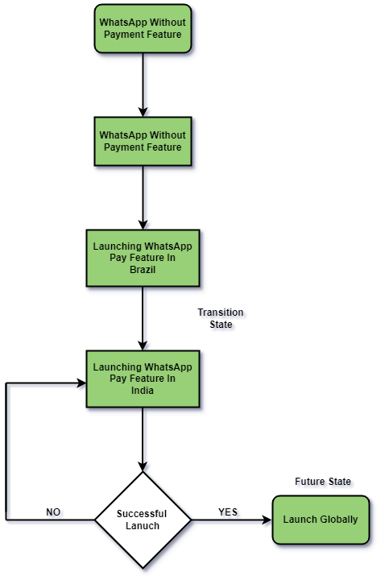

1. As-is and future process map

## Current Process of WhatsApp Pay:

* + The Current System allows users to use WhatsApp for messaging and calling.
  + User can install WhatsApp from Play store and install on their phones and register themselves in WhatsApp for the first time.
  + Registered user can chat or call their contacts via this app and also pin their chats, delete, mute, achieved or unread.
  + User can create a group (one or more than one contacts) send messages or call (voice or video call) in group.
  + Broadcast group can be created for sending messages to huge contact list.
  + User can customize their WhatsApp account details like Display name, profile picture, status and also configure account details, chat and notification, storage under settings menu.
  + In addition, WhatsApp also stores and creates backup on daily basis, when user re-login to the application backup can be restored the chats and ensure to be up to date.

Current Process:

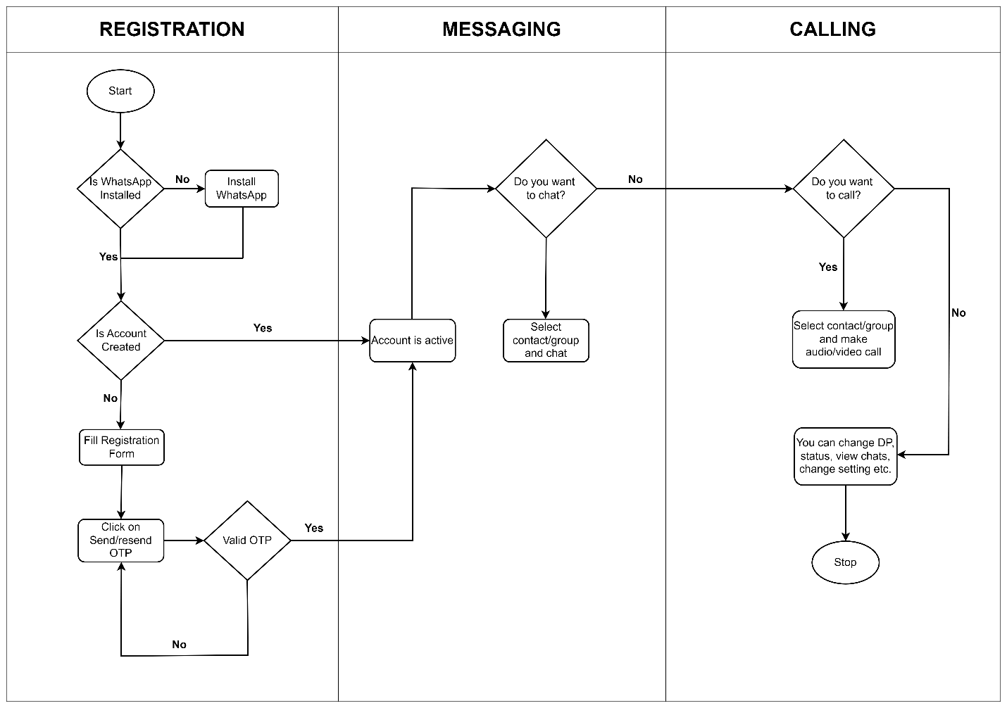

## Future Process of WhatsApp Pay:

* + In addition to the above features, digital payments feature is added to the WhatsApp.
  + User will have to configure debit or credit card details of their bank accounts.
  + WhatsApp will ensure the details are authenticated by checking the cards authenticity from banks system.
  + If the cards will be authenticated, then WhatsApp will allow users to make payments, failure in authentication then payment will not be allowed.
  + Digital payment to their contact is allowed only after card details ae registered by the user.
  + User can go to contacts chat and select ‘payment’ from the menu, enter the amount and followed by security pin which will be preconfigured. If security pin is valid the payment would be successful, else payment operation will be aborted.
  + Another approach is via QR code. You can go to payments from the menu tap on the QR code showing next to their name to show their QR code using which people can send them money. User then will have to tap on the new payment option located on the bottom right of the display.
  + User selects a contact or scan the QR code option. Transaction history will be maintained for the user.

Future Process: 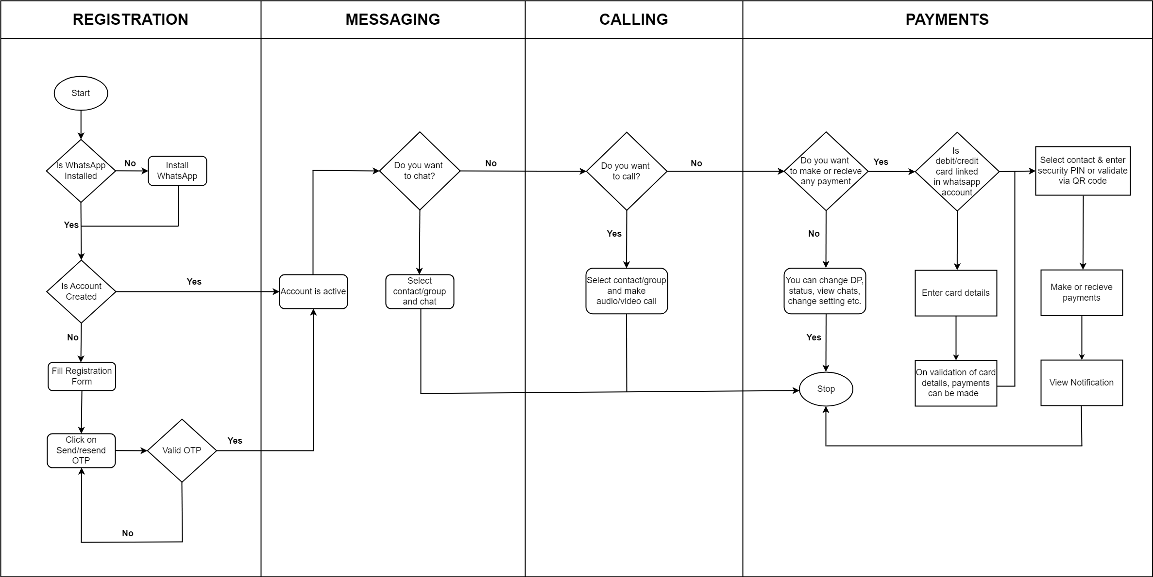

8. In-Scope and Out-of-Scope

## In Scope Requirements:

1. Addition of Bank accounts to WhatsApp User Account.

2. Linkage of Debit and Credit cards to WhatsApp User Accounts.

3. Additional credentials management making Digital Payments.

4. Payment or Receipt of funds to/from Contacts via WhatsApp Digital Payments.

5. Notification of Payments/Receipts of transactions done via WhatsApp Pay.

6. Digital Payments through QR Code.

7. Integration with Banks, Payment system operators and Payment Gateways for seamless transfer of funds.

8. Payments Process to follow local and global guidelines and protocols for secure transactions.

9. Payment feature would be available in multiple languages.

10. Display of Transaction History will be available to the users.

## Out of the scope requirements:

1. WhatsApp pay will not be accessible to users who do not have WhatsApp Account.

2. Payments would not be allowed for users whose Bank Accounts are not added.

3. WhatsApp Wallet is currently out of scope.

9. Business Requirements

## Functional Requirements:

1. **Linkage of Debit and/or Credit Card to WhatsApp Account**: System will allow WhatsApp Users to add their bank accounts by providing the option to configure their account from Settings.

* + User can go to Payment Account Details sub menu under Settings menu.
  + In Payment Account Details, user can view his/her debit and/or credit card details if already added to the system. Users can remove their card details if they wish to.
  + To add new card details, user can click on add and can fill in all the details on the form like Account holder name, Account number, IFSC Code and Card Validity period.
  + All the details entered by the user would then be sent to Bank’s system to validate and authenticate the card details entered by the user. On fetching authentication on the same, user card will then be linked to WhatsApp User’s Account.

2. Users can make digital payments only if there is at least one authentic card linked to their WhatsApp Account. Moreover, the transfer can only be done to the contacts of the WhatsApp User.

3. **Process of payments made to and from WhatsApp users accounts**: There can be two approaches for making digital payments.

## Approach 1:

* To use the WhatsApp, pay feature the user needs to have a bank account with its debit card or a credit card
* Users shall select the person they want to send money to from their WhatsApp contact list
* Users shall click on payments option in their chat settings
* Users shall enter the amount they wish to transfer
* Users will then enter a security Pin
* Users will click on the transfer button
* Money is transferred
* The sender and the receiver will both receive a payment notification on their chat window once the fund transfer has been made.
* In cases where the user is requesting money, tap on request and wait for the person to accept your request.
* The feature should be available in multiple languages

## Approach 2:

* User goes on the main page of WhatsApp and opens the payments option.
* User then taps on the QR code showing next to their name to show their QR code using which people can send them money.
* User taps on the new payment option located on the bottom right of the display.
* User selects a contact or the scan QR code option.
* The rest of the process remains the same as above.

4. **Transaction History**: Users will be able to view their transaction history.

## Non-Functional Requirements:

1. The system should be scalable to cater to more users when launched in modular manner.

2. All the transactions details should be encrypted to ensure that data at rest and in motion is secured.

3. Performance of the system irrespective of number of users using the system should be under acceptable limits.